TS2  
MATERIALS  
WK 2

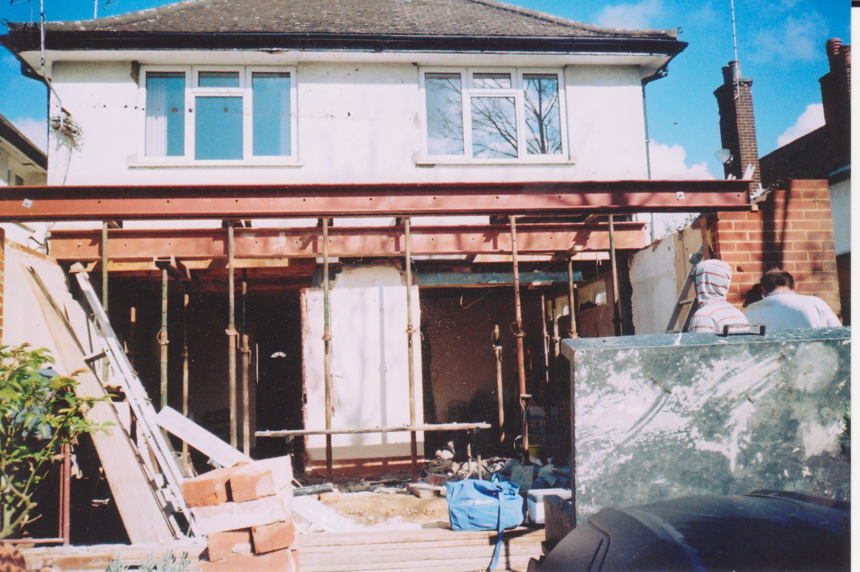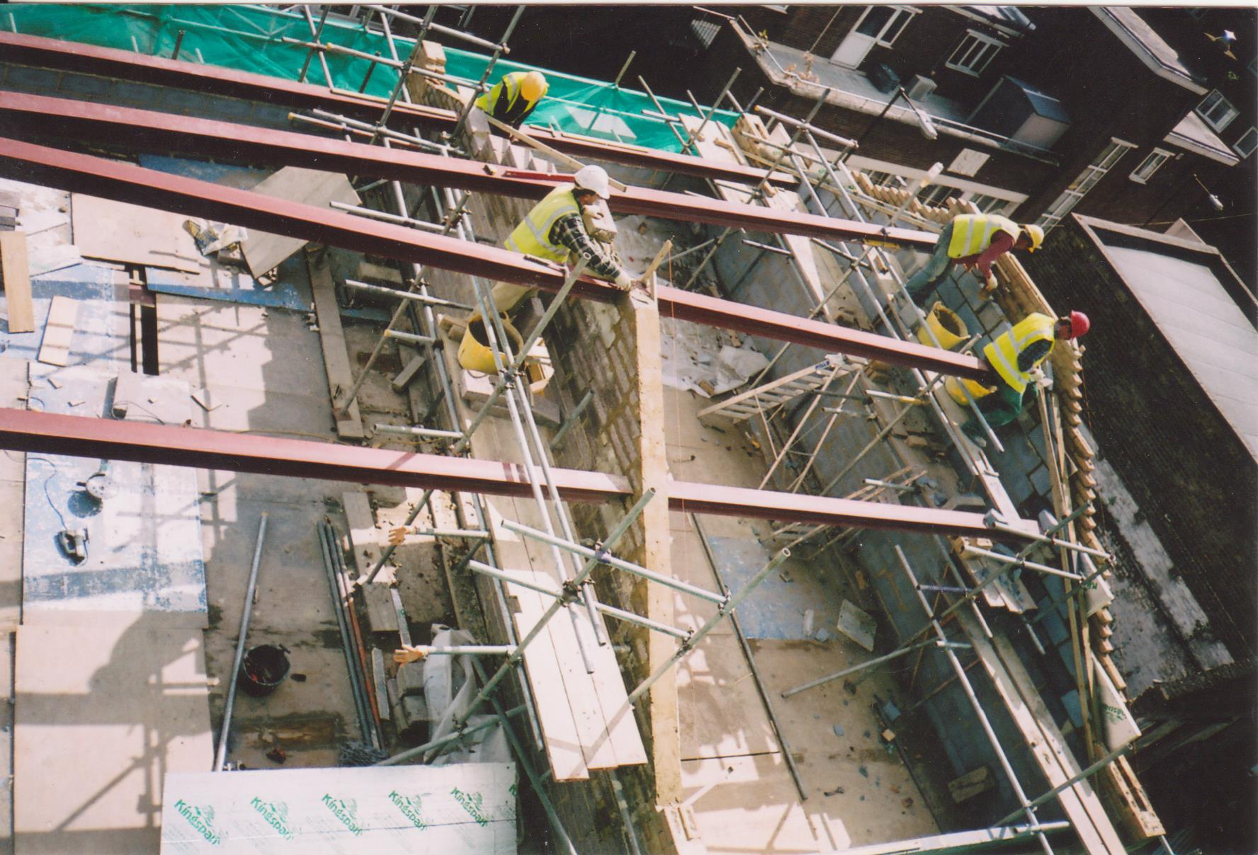. . .   
  
Architect: No architect involved  
Engineer: Lawrence Goodman  
  
Load-bearing strutting beam;   
10,000mm span, 203 x 203mm cross section.  
  
Steel: resistant to corrosion, durability, high compressive strength.  
The beam can save 10%-15% material and can be easier to utilize when constructing flamboyant designs.   
Lighter than concrete means it is easier to carry without compromising on stability and can be used in earthquake-prone zones.   
Steel beams also reduce the overall dust polluting building sites and can be used regardless of the weather conditions.  
  
No joints involved in the H beam - rolled steel beams are manufactured by passing pliable metal through sizeable rollers to flatten and mould it into the intended shape. This shape is also advantageous as it helps to reduce the overall weight of the structure. Galvanised: coated in a protective layer of zinc to prevent rusting.   
  
With a theoretical weight of 17.2-28.3kg/m, the beams should weigh approx. (avg.) 22.75 x 10 = 227.5kg but likely to be less dense at 172kg as the project is at a small scale, where extensive beams are not necessarily required.  
  
  
  
  
  
Sandra Kolacz