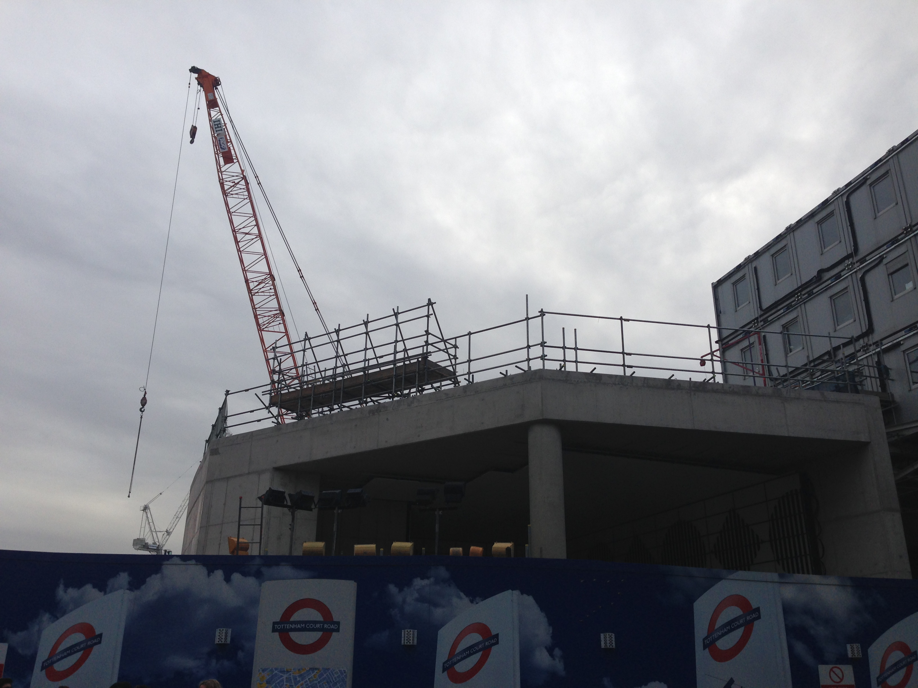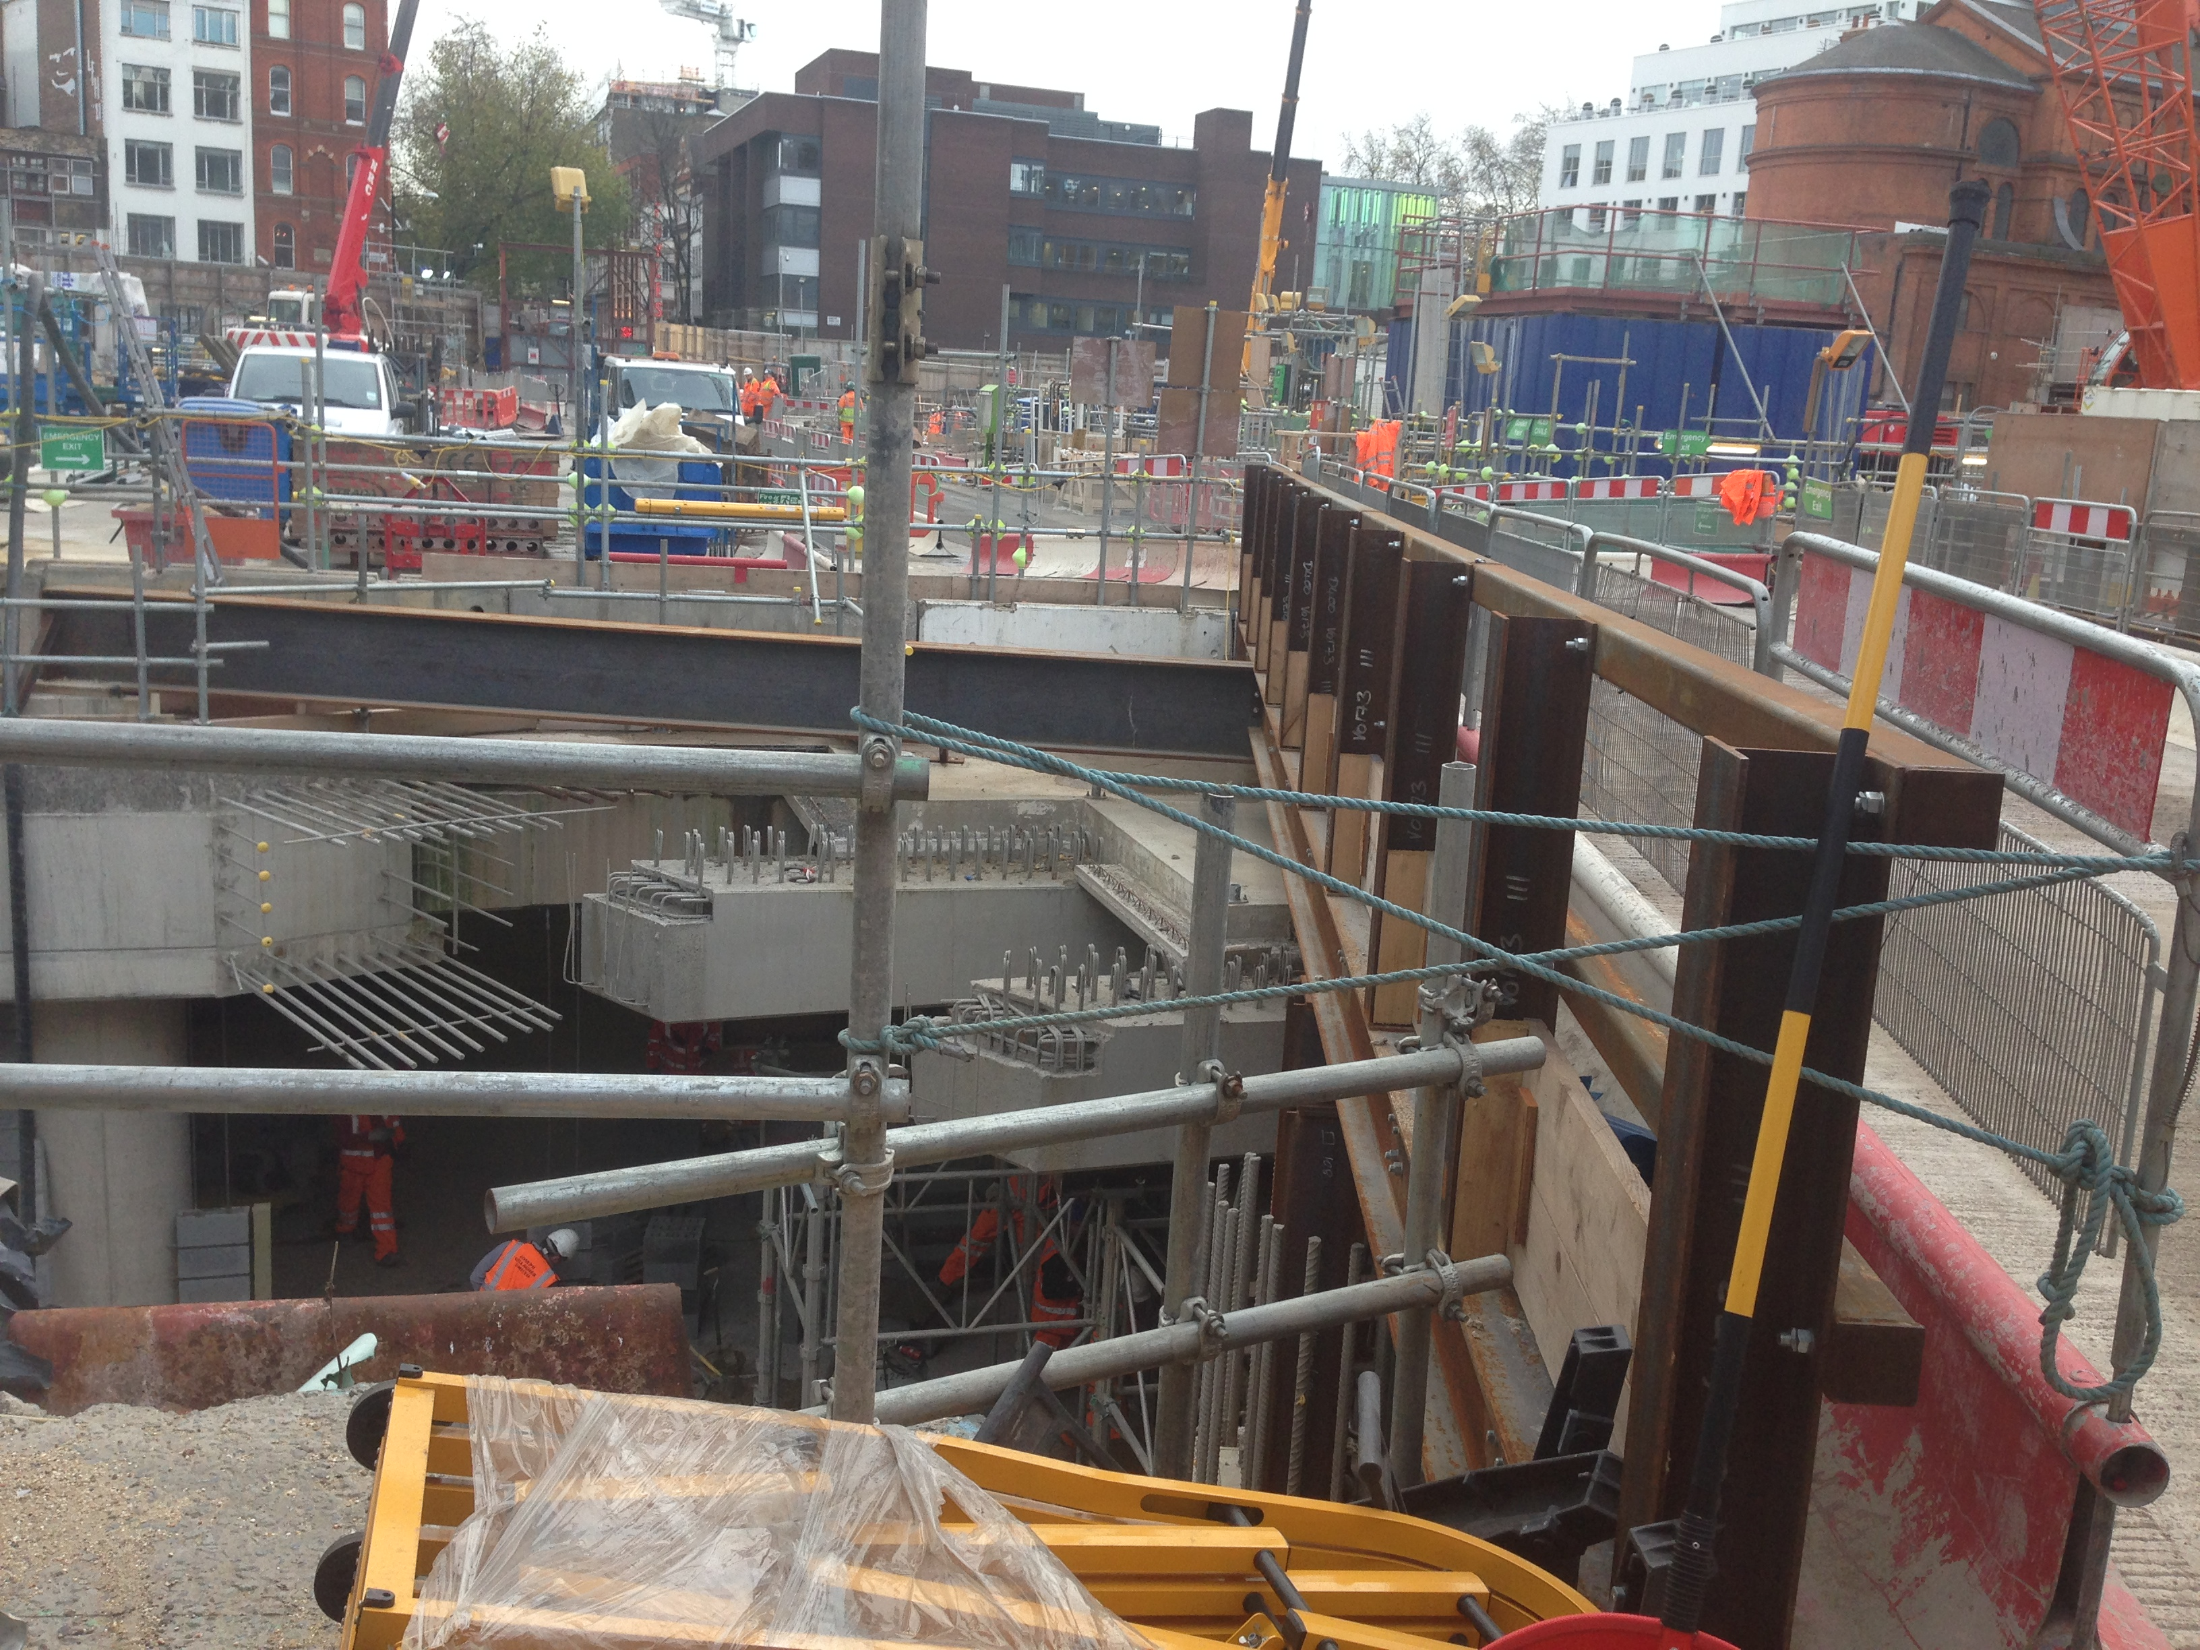

Tottenham Court Road Station Upgrade, Tottenham Court Road, London, WC2H

PROJECT INFO : Architect Hawkins/Brown

Civil Engineer Taylor Woodrow BAM Nuttall

Main Contractor Taylor Woodrow BAM Nuttall

BUILDING COMPONENT: Reinforced concrete beams

Lower ground floor

The Beams are made out of reinforced concrete that is molded in situ. Made out of dry pre-blended reinforced. this overcame the highly constrained site conditions and produced very high quality concrete.

The beams measure (from rough observation) no more than 1m in height and width and have an “unpredictable” span since it has already been covered up.

I believe concrete was used for its very versatile application that can be freely molded into any given shape, apparently necessary due to the limited space on the site, and it’s the reinforcement gives it the necessary strength to bear the dead (flooring) and live loads (people walking, cars, etc..) How the vibration derived from the constant train movement is going to be tackled is something that interested me, but that I couldn’t exactly pinpoint, for in this case I would think that steel would be used for the beams intead of concrete.